If you have the Nokia app, please follow the directions below. If not, see the instructions to reset manually at the end.
WARNING:
FACTORY RESET WILL RESET ALL PASSWORDS OR NAMES THE CUSTOMER HAD CHANGED FOR THE NOKIA! You will need to reconfigure the Wi-Fi name and password (use what you had previously so that devices will reconnect).

LOG in to the NOKIA portal:

Go to the right-hand side of Support Actions 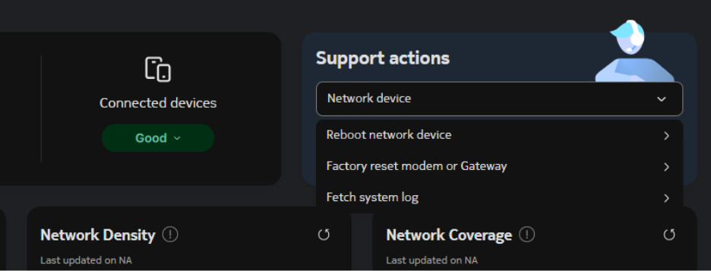

Click ‘FACTORY RESET MODEM OR GATEWAY’

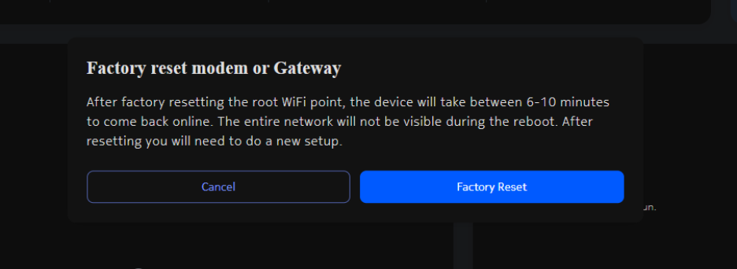
This warning will come up, click FACTORY RESET.
ONT will go down for 6-10 minutes.

SHOULD COME BACK UP.
NO NOKIA APP:
If you do not have the Nokia app, find the reset button at bottom of the router and push and hold for 15 seconds. It will take 6 to 10 minutes to reset.

